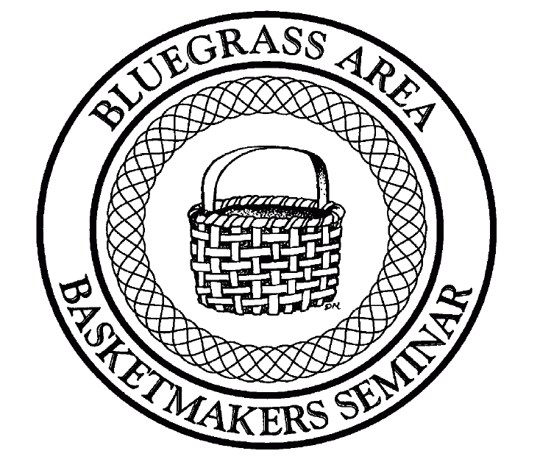
Teacher Proposal
Bluegrass Area Basketmakers Seminar
Jabez, Kentucky
June 16-20, 2020

Please fill out a separate form for each basket submitted.

Teacher Basket

Name __________________________________ Name ________________________________
Address ________________________________ Size __________________________________
________________________________________ Price _________________________________

Telephone ______________________________ Weaving Level _____ Beginning
_____ Intermediate
_______________________________________ _____ Advanced
_____ All Levels
E-Mail address: _________________________________________________________________

Special tools needed:_____________________________________________________________

Hours needed to make basket: _____ 2 hours _____ 4 hours _____ 6 hours

_____ 8 hours _____ 10 hours _____ 12 hours

Seminar will last 5 days, do you wish to teach: _____ Tuesday afternoon/evening

_____ Wednesday _____Thursday _____Friday ______ Saturday _____Evening classes

How late are you willing to teach? _______________________________________________

Include a short description of the basket as you would like to have printed in the catalog if you are selected.

Place Picture of Basket Here

Please place measurement reference such as a ruler when taking picture.
(Solid white background in picture makes basket show up better in the catalog)

Picture will be returned by mail or at the Basket Seminar.

Information must be postmarked by October 1, 2019.
Later postmarks will not be accepted.

Will you be vending? ________ yes _______ no

Would you be interested in teaching a technique for 1 or 2 classes at night? ______ yes ______ no
If yes, please submit pictures, descriptions, etc.

Brief teacher biography in 100 words or less as you would like to have it printed in the catalog if you are selected. (This needs to be filled out only once if you are submitting more than one basket.) Also, please provide us with a personal picture of yourself for the 2020 catalog.

We look forward to having you submit your pictures. Please note that submitting pictures does not guarantee acceptance. The classes are chosen by a panel of basketmakers. You will be notified by December, 2019 if your classes have been accepted for the Basketmakers Seminar 2020.

Send your pictures along with the required information to:

Nancy Lake
6870 Cartersville Road
Berea, KY 40403
(859) 986-8306

